**DAILY ONLINE ACTIVITIES SUMMARY**

|  |  |  |  |  |  |  |  |  |
| --- | --- | --- | --- | --- | --- | --- | --- | --- |
| **Date:** | **22/06/2020** | | | | | **Name:** | **Shwetha** | |
| **Sem & Sec** | **8th B** | | | | | **USN:** | **4AL16CS101** | |
| **Online Test Summary** | | | | | | | | |
| **Subject** | | **SMS** | | | | | | |
| **Max. Marks** | | **30** | | **Score** | | | **No mail received.** | |
| **Certification Course Summary** | | | | | | | | |
| **Course** | **Artificial intelligence in python** | | | | | | | |
| **Certificate Provider** | | | **Great learning** | | **Duration** | | | **7hr** |
| **Coding Challenges** | | | | | | | | |
| **Problem Statement:**  **Program to rotate bits of number in python.** | | | | | | | | |
| **Status: Solved**  **Solution link: https://github.com/alvas-education-foundation/Shwetha-** | | | | | | | | |
| **Uploaded the report in Github** | | | | | **Yes** | | | |
| **If yes Repository name** | | | | | **Shwetha-** | | | |
| **Uploaded the report in slack** | | | | | **Yes** | | | |

Certification Course Details:

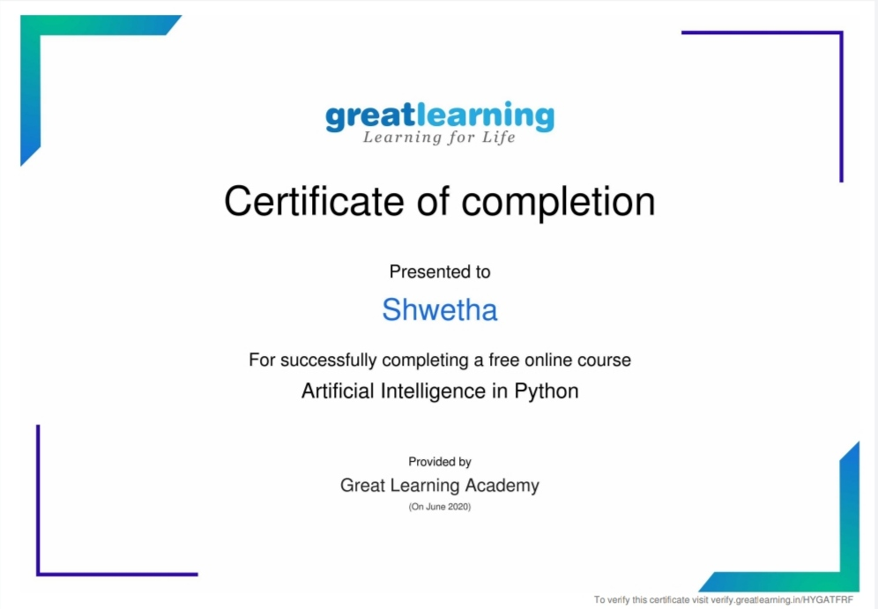

*Coding Challenges Details:*

INT_BITS = 32

def leftRotate(n, d):

return (n << d)|(n >> (INT_BITS - d))

def rightRotate(n, d):

return (n >> d)|(n << (INT_BITS - d)) & 0xFFFFFFFF

# Driver program to

# test above functions

n = 16

d = 2

print("Left Rotation of",n,"by"

,d,"is",end=" ")

print(leftRotate(n, d))

print("Right Rotation of",n,"by"

,d,"is",end=" ")

print(rightRotate(n, d))